Setting up ECR (Elastic Container Registry)
Step 1:
Open AWS Console and Search ECR
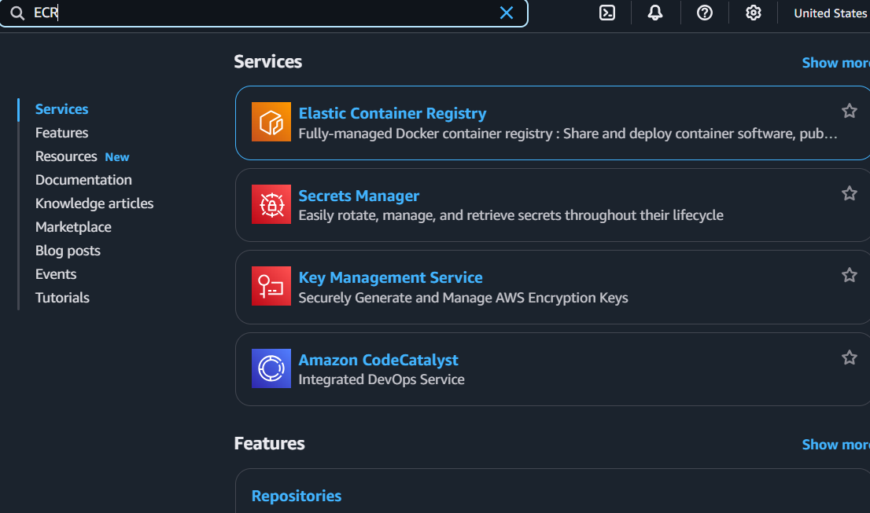
Step 2:
Select Create Repository
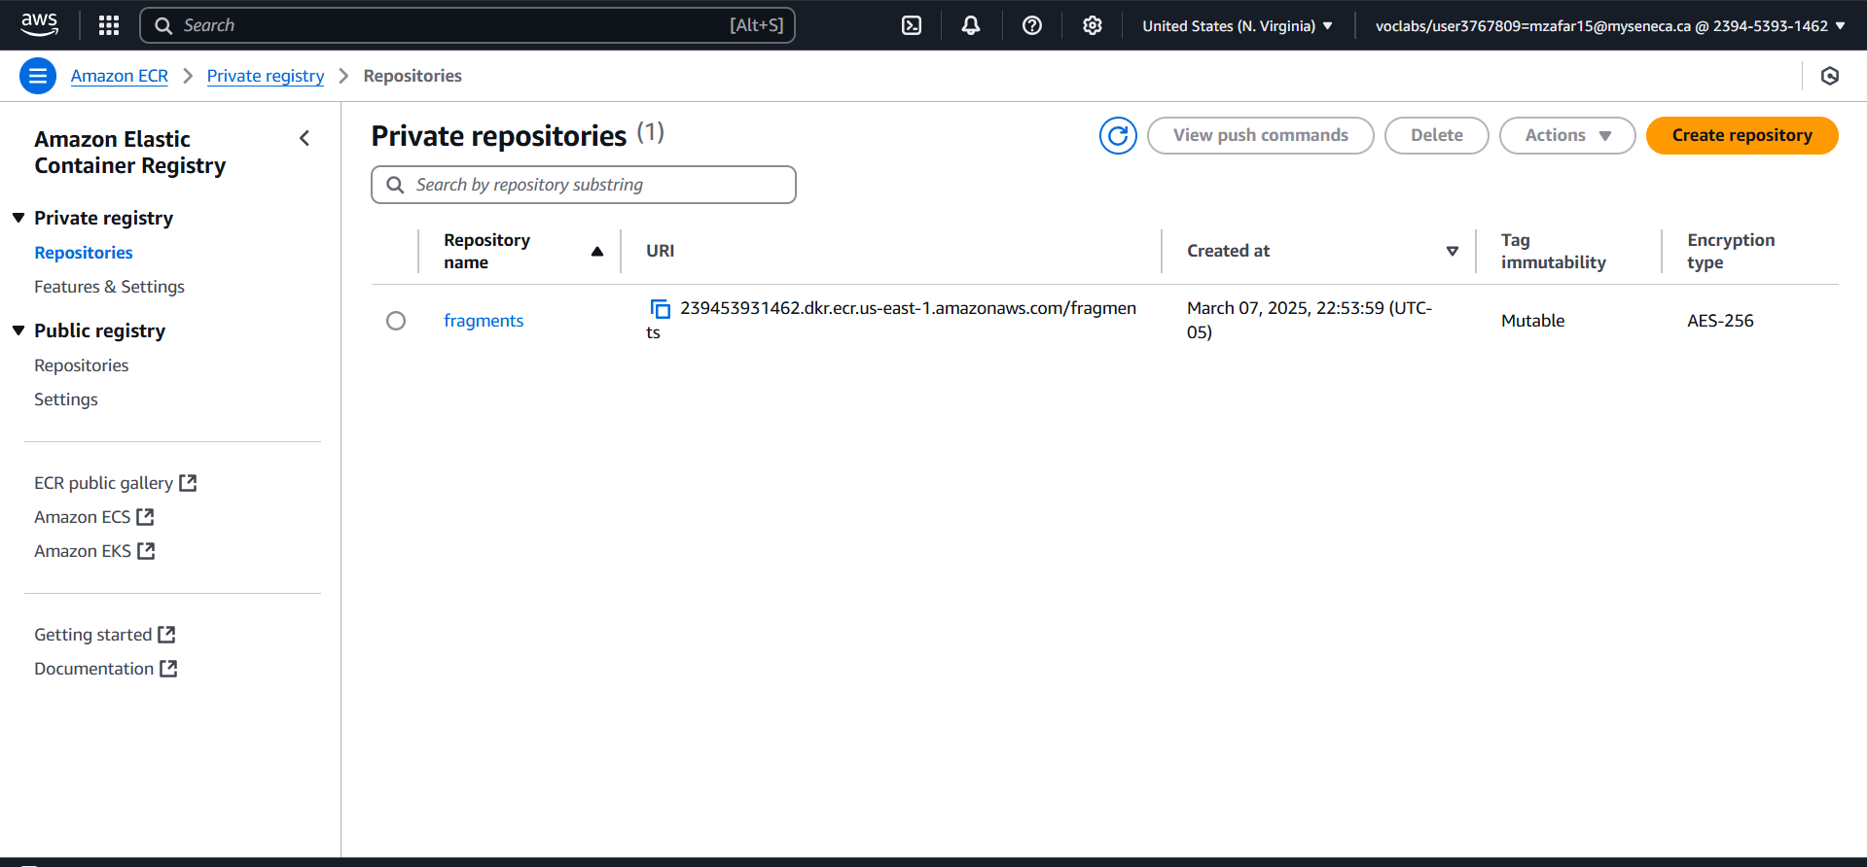
Step 3:
Set the name of the repository
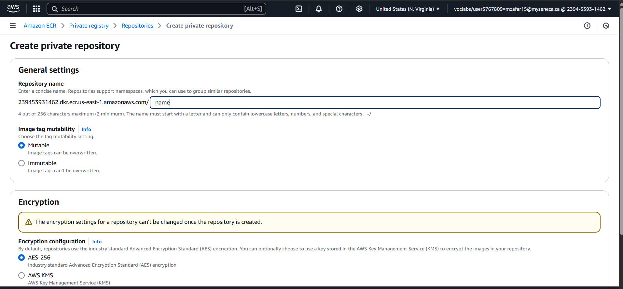
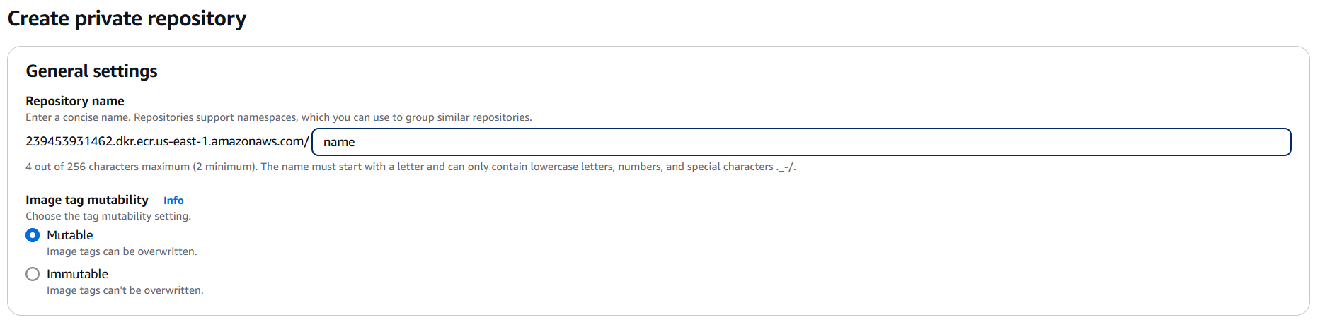
Step 4:
Click Create
